SPARK: Simple Play Adaptations to Reference for Kids

Logan Prox Talker
Description: | Image:
The Logan® ProxTalker® is an adaptable recorded speech communication device. It enables independent verbal picture communication by placing any photo, symbol, or object on a sound tag card. It is portable in (included) backpack or wheelchair/wall mountable in a binder format. The Logan® ProxTalker® is 15" long X 14" wide X 1.5" deep. Its weight in backpack (with Tags) is 4.7 pounds. To trigger voice output, place the sound tag card on any one of the 5 buttons and push.  Standard package includes:  - 80 prerecorded sound tags  - 60 blank small tags  - Choose a binder or backpack with 4 page Velcro® set  - 2 sets of programming tags  - Peel and stick labels and laminates  - Tool kit | 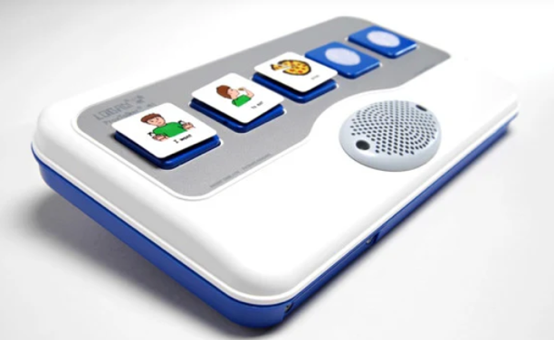  Purchasing Information  Demo Video  Quick Start Guide (1 page)  Users Manual

Who Might Benefit?
Those who…
• Need communication supports due to challenges with verbal communication.
• Have adequate fine motor skills to isolate a finger to poke the communication cell or press a switch to activate the device. This skill is specific to this device, however there are many different access methods that can be used with other communication devices if needed.
Why Use?
Provides an opportunity to…
• Make choices.
• Engage simple communication exchanges with peers, staff, and parents.
Instructions for Use: | Adaptation Ideas:
Environmental Considerations  - Easily use in almost any environment because of the small size, weight, and easy transportability.  - May be difficult for some communication partners to hear in unusually loud environments.  - Use each recording level to record messages based on the environment like the classroom, lunchroom, playground, bus, and at home.  - The user of the device will need to learn when it is appropriate to use the device in quiet environments in the same way that children who are speakers learn when they need to talk or not talk in quiet environments.  - If used as a part of a child's total communication system it should be available in all the child's environments, at all times, and without restriction.  Positioning  - Use laying on a flat surface such as a table or on the floor. It would be possible to mount the device on an articulating arm mount if needed. A child could interact with the device in a position such as sitting, standing, prone (Tummy Time position), supine (laying on their back), kneeling, etc.  Alternate Positioning  - Also use on a slant board to improve physical and/or visual access of the device to the child.  Basic Play/Use  - The LoganTech website provides multiple resources that provide clear and concise directions for setting up the device along with troubleshooting common problems encountered by new users. Pictures are also included to support the written directions if needed.  - Messages will need to be recorded for the additional 60 blank tags included. It is recommended that a child similar in age and gender of the child who will be using the device provide the recordings.  - Recorded messages (words, phrases, and sentences) need to be relevant to the child’s immediate activities.  - In the most simplistic way the device can provide a child with an opportunity to communicate a clear spoken message to a communication partner. However communication is complex and has many purposes.  - It is important to note that young children need intentional and consistent exposure to communication opportunities. They should be provided with specific instruction using a communication system. In particular children need to develop the ability to understand that a particular symbol (e.g. real object, photo, line drawing, etc.) represents an action or object and that their use of that symbol is respected by their communication partner so that successful and effective communication can develop  - The chosen communication system should be referenced and modeled by classroom staff.  - Introduce the visual to the child and explain what you are going to be using it for.  - If using objects, they need to be meaningful and motivating for the child.  Extended Play/Use  - Instruction: Provide directions, such as what to wear or what's next on the schedule.  - Requests/Choices: Make requests, such as choosing snack food, asking a question, requesting a song, selecting a toy, requesting more, choosing a musical instrument to play at circle time, indicating a need for a sensory break (I need headphones, I need to jump/run, I need to swing), etc.  - Participation: commenting on the weather (rainy, sunny, snowy, etc.) during circle time, speaking the repeating lines of a book for choral reading with other children, one to one counting of objects out loud.  - Information sharing: Share information, such as upcoming events or activities, sharing the day and month during calendar activities.  - Communication: Add communication to toys or appliances. | Optional Additional Materials/Supplies  - Velcro, Dycem, cabinet liner  - Objects  - Photos  Build It Up  - If the size of the cell is too small for the child to activate there are other single message devices available in the OCALI Lending Library that have larger activation surfaces.  Simplify It  - Introduce the levels gradually or consider using fewer cells.  - Use objects or photos instead of the provided symbols.  Stabilize It  - Velcro on most surfaces or place Dycem to help stabilize it so it doesn’t move away when the child tries to activate the button.  Add Sensory Cues  - Add to the tags- puffy stickers, puffy paints, different textures.  Alternative Uses  - In addition to the basic function as a communication device this product also provides an opportunity to directly connect battery operated switch toys and games to the device so that speech output can be connected to the actual actions of the activity.  - One of the eight levels of the device can be dedicated to classroom weekly theme, responses to calendar queries, counting, or a storybook and be changed out and re-recorded as needed.  - Consider using as a non-individual student device available to classroom peers, to support center activities (i.e. provide step-by-step directions, vocabulary enhancement/building) or for adult modeling of AAC use.  DIY Alternatives  - Paper communication systems can be used when speech generating devices are not available or are not appropriate for the activity (e.g. water play where exposure to moisture may damage the device, loud environments where the speech generated by the device can not be heard, etc.). Paper communication systems can be made by using one of the overlay maker products such as Boardmaker or LessonPix. They can also be hand drawn and created.  - Paper boards are often laminated or put into plastic page sleeves to protect the board. There are also commercially available communication books that can be purchased that can display personalized overlays

Additional Considerations:
- Please keep in mind the device only has 5 message spaces on the surface and until the user is familiar with the device and can select communication tags, the communication partner may need to anticipate the child’s communication needs/comments.
- 4 AA Batteries are required.

Resources:
Note: Research has shown that early use of a communication device does not impact a child’s ability to develop oral speech later and will actually often help to enhance development of oral speech

